EXPERIMENT- 34
Morphological Operations using Top Hat Technique
Aim
To write a Python code to perform Top Hat transformation using OpenCV for extracting bright regions from the image.
Input Image
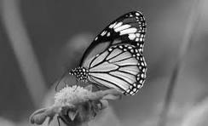
Code
from google.colab import files
import cv2
import numpy as np
from google.colab.patches import cv2_imshow
uploaded = files.upload()
image_path = list(uploaded.keys())[0]
image = cv2.imread(image_path, cv2.IMREAD_GRAYSCALE)
kernel = np.ones((5,5), np.uint8)
top_hat = cv2.morphologyEx(image, cv2.MORPH_TOPHAT, kernel)
cv2_imshow(image)
cv2_imshow(top_hat)
Output Image
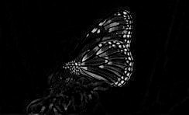
Result
Thus, the Top Hat transformation was successfully performed using OpenCV.

